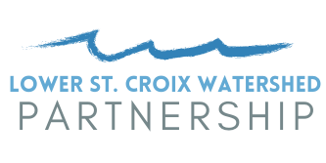
Project Selection Criteria
Activity 6 – Wetland Restoration

The Activity 6 Subcommittee will use the following criteria to rank and select wetland restoration projects to be recommended to the Steering Committee. Submit an application to becky.wozney@anokaswcd.org. The Deadline for applications is June 30, 2022. The Wetlands Subcommittee will review projects and make recommendations to the Lower St. Croix Advisory Committee, which in turn makes a recommendation to the Policy Committee. Final funding decisions are made by the Chisago SWCD. Final funding decisions are expected by September 30, 2022. Construction must be complete by December 31, 2023.

Required:
- Must be in the priority watershed. Areas of particular concern are direct drainage to St. Croix, Sunrise River corridor, Rock Creek corridor and subwatersheds identified in Figure 5-5 of the LSC CWMP.
☐ Yes ☐ No
- Not be a wetland banking project for financial gain.
☐ Yes ☐ No
- Not associated with correcting a wetland violation.
☐ Yes ☐ No
- Evaluated by a STEPL EPA model or similar. Provide results in application.
☐ Yes ☐ No
- Grant funds will only be used for construction, not design/engineering.
☐ Yes ☐ No
- Someone must be willing to maintain project for 10 years.

Scored:
- Vetted in a prioritization study (High-10, Medium-7, Low-4 (see Figure 5-5))
- Phosphorus reduction. Applicant must specify method used to estimate pollutant reduction (Over 10 lbs-20 points, 5-10 lbs-10 points, 1-5 lbs-5 points, less than 1 lb- 0 points)
- ____ out of 10 Timeliness. Date of anticipated construction.
- ____ out of 10 Site readiness. Owner signed a project contract. Legal hurdles, such as those associated with public ditches or flowage easements, consent from mortgage company, are not a concern.
- ____ out of 5 Finances. Amount of match and is it secured?
- ____ out of 5 Finances. Will the project only occur if this grant is awarded?
- ____ out of 5 Location. Is there direct benefit to priority receiving waters? Or is there possible other treatment between the project and receiving waters?
- ____ out of 5 Cost/Benefit. Is the project configured to maximize treatment? (for example, cost/benefit of multiple smaller wetlands vs one large)
- ____ out of 5 Likelihood of success. Invasive species, landowner conflicts, someone with appropriate equipment and skills is accepting maintenance, etc.
- ____ out of 75 TOTAL

References: Minnesota Stormwater Manual Available stormwater models and selecting a model - Minnesota Stormwater Manual (state.mn.us)
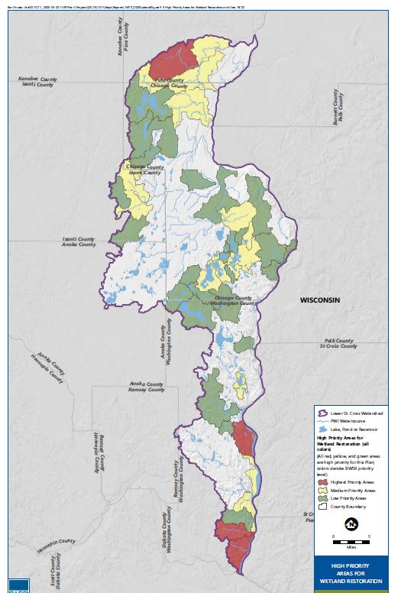
Figure 5-5

