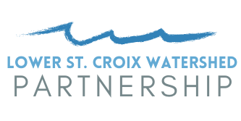
Request for Funding
Activity 7 – Internal Analyses

Activity 7 Description
The 2021 Lower St. Croix 1W1P Watershed Based Implementation Funding grant includes calculating internal loading of phosphorus on two lakes estimated at $25,000 each. Work is anticipated to be completed by a consultant. This request for funding describes how parties can be considered for the funds.

Qualifying Project Applicants
A lead or sponsoring agency is required for each submitted project. That agency must be a party to the Joint Powers Agreement for the implementation of the Lower St. Croix Comprehensive Watershed Management Plan. The sponsor, if the project is selected for funding, will enter into a subcontract with the Chisago Soil and Water Conservation District (SWCD) for project funding.

Process for Requesting Funding
- Call for projects (due Oct 31) - The Internal Loading Subcommittee will send an initial request for projects to all qualifying entities. Responses must only include the lake and description of work anticipated. All respondents will receive a complete list of responses and any subcommittee feedback so they can decide if they wish to apply. Deadlines, both for the call for projects and application will be provided.
- Application (due Dec 15) - Fill out the application below, along with the Project Request Form attached, and submit to Susanna Wilson Witkowski Susanna.Wilson@chisagocounty.us. The application requires securing a contractor’s quote for the work.
- Internal Loading Subcommittee review. The subcommittee will provide a recommendation to the Steering Committee.
- Steering Committee review. The Steering Committee provides a recommendation to the grant fiscal agent, Chisago SWCD.
- Sponsors of successful projects will execute a subcontract with Chisago SWCD. Grant funds expire Dec. 31, 2023.

Required Internal Analyses Elements
The following are required outputs of the internal analyses. The intention is to position projects for state competitive grant implementation funding. These elements are from the 2022 BWSR Clean Water Fund RFP. Please ensure consultant quotes for the work include all these elements.
- Lake and watershed information (at a minimum, include morphology and depth, summary of water quality information, and assessment of AIS);
- Description of internal load vs external load nutrient reductions;
- History of projects completed in the watershed, and their associated nutrient reductions, as well as other in-lake activities if applicable.
- Cost benefit analysis of options considered;
- Projected effective life of the proposed activities;
- Expected water quality outcome;
- Plan for monitoring surface water quality to assure the project’s total phosphorus goal will be achieved during the project’s effective life, and
- For activities related to rough fish (example, carp) the feasibility study must also include:
  - Methods used to estimate adult and juvenile carp populations;
  - Description of the known interconnectedness of waterbodies;
  - Identified nursery areas;
  - Methods used to track carp movement;
  - Proposed actions to limit recruitment and movement; and
  - Proposed actions to reduced adult carp populations.

Eligible Waterbodies
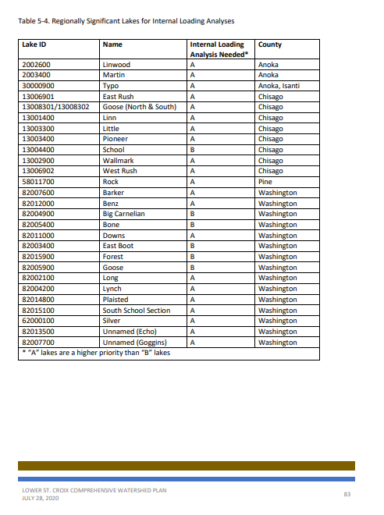

Activity 7 – Internal Phosphorus Analyses Project Funding Application

Project Summary
Sponsoring Entity
Project Name
Project Location (lake name)
Lake DNR ID #
Applicable WBIF Work Plan Activity | Activity 7 – Internal Analyses
Estimated Completion Timeline

Lake Summary
Mean and max depths
Recreational uses
Impairment status and description of degree of impairment:
Describe any previous internal loading projects:

- Waterbody to be analyzed is a Priority A or B lake in the LSC CWMP (Table 5-4, see following pages)? ☐ Yes ☐ No

- Waterbody has had a TMDL, WRAPS, or similar study that identified internal loading as an important pollutant source to be addressed? ☐ Yes ☐ No

- When would the internal analysis be completed? (grant funds expire 12/31/2023)?

- Describe plans and any financing to implement internal load treatment based on findings from the internal analyses report.

- To what extent has watershed external loading of phosphorus been addressed? Measurable outcomes such as pounds of pollutant reduced compared to the needed reductions are appreciated. (If possible, provide an estimated percentage of the watershed loading that could be reasonably be addressed, and has been. And, if a project identification and prioritization study is done, how many of those projects have been installed and could still reasonably be installed?)

- To what extent is addressing internal loading a critical part of successfully meeting the waterbody’s water quality goals? Please include information from any TMDL or similar study.

- Please attach a consultant’s quote for performing the internal loading analysis.

