Lower St. Croix Watershed Partnership
FY21 WBIF Grant Agreement Amendment Timeline (DRAFT)

- July 13, 2022 – LSC WP SC recommends shifting funding between WBIF grant activities in excess of $50,000 to fund requested projects (CLFLWD and/or SWWD).
  - Per the October 25, 2021 LSC WP PC meeting minutes, all shifting of funding between grant activities in excess of $50,000 requires PC recommended approval.
  - Per the April 25, 2022 LSC WP PC meeting minutes, all project request in excess of $50,000 require PC recommended approval.
- July 25, 2022 – LSC WP PC votes to recommend a proposed work plan amendment to the governing boards of the JPA. A vote of 2/3 of the members present is necessary to move a recommended work plan amendment onto the governing boards.
- August, 2022 – Per our Joint Powers Agreement
  - The governing boards of the Parties have the responsibility to take approval action on matters required by the terms of this Agreement and on matters recommended by the Policy Committee. Matters on which governing boards must take formal action include, but are not limited to, as follows:
    - Designation of an elected or appointed member or members to serve on the Policy Committee and set the term of service of each member so designated.
    - Approval of Annual Work Plans;
    - Amendments to the provisions of the Plan; and
    - Adoption or approval of other matters necessary for Plan implementation.
- September, 2022 – If approved by the governing boards, the Chisago SWCD submits a Grant Agreement Amendment request to BWSR Board Conservationist, Michelle Jordan.

BWSR Grants Administration Manual (https://bwsr.state.mn.us/grant-agreement-amendments-and-work-plan-revisions)
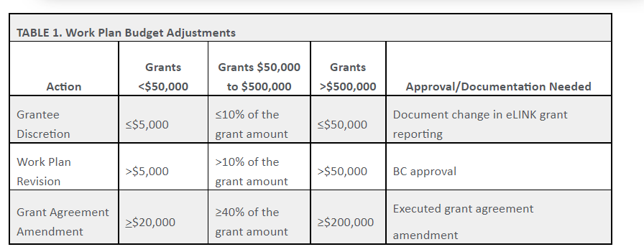

- October (or later), 2022 – BWSR approval received for Grant Agreement Amendment, Chisago SWCD executes sub-agreement with LSC WP partner (CLFLWD and/or SWWD) for the funding outlined in the revised LSC WBIF grant agreement work plan.

