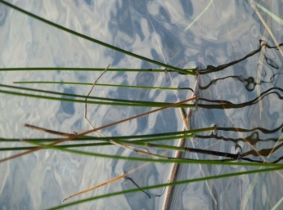

Laura Jester
16145 Hillcrest Lane
Eden Prairie, MN 55346
952-270-1990
laura.jester@keystonewaters.com
Keystone Waters, LLC

December 28, 2022
Mr. Craig Mell
Chisago SWCD
8814 3rd Ave.
North Branch, MN 55056
Dear Craig,
I greatly appreciate the opportunity to submit a proposal to assist the Lower St. Croix Partnership with grant and progress reporting on implementation of the Lower St. Croix Comprehensive Watershed Management Plan. Due to my past involvement in helping to write the LSC Plan, I believe I am well poised to provide implementation reporting services. Thank you for recently meeting with me to discuss how the Partnership is currently preforming grant and progress reporting. I also spoke with Emily Heinz to better understand her current role and work tasks. Between the Partnership’s grant reporting responsibilities, need for quarterly progress reports for the Policy Committee, and desire for a more streamlined process for tracking implementation of non-grant activities, I propose three primary areas of work, plus some time allocated to meeting attendance, as needed (see table below).
I propose a contract for 110 hours per year for grant tracking, quarterly reporting, virtual meeting attendance (as needed), and basic progress reporting of non-grant activities (consistent with current processes). I can also assist with development of a more streamlined method for tracking non-grant activities for an additional one-time expense of 20 hours.
Please let me know if you have any questions or if you would like this proposal revised in any way. I am happy to further discuss these tasks and estimated time allocated to each. I look forward to working with the LSC again!
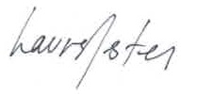
Sincerely,

Proposal for LSC Implementation Reporting
Work Activity | Estimated Hours  per year
Tracking and Reporting Watershed Based Implementation Funds  - Work plan tracking and reporting in eLINK (2021-2023 grant)  - Work plan tracking and reporting in eLINK (2023 – 2025 grant)  - Quarterly progress report development for Policy Committee | 70 hours
Tracking and Reporting Non-grant Activities  - Use current methodology to gather and report on data/information from partners | 30 hours
Meeting Attendance  - Attend Policy Committee and/or Steering Committee meetings, as needed (assumes virtual attendance) | 10 hours
Update Method for Non-grant Activity Data Gathering and Reporting  - Assist with the development of a more streamlined method for gathering information from partners on non-grant activities (assumes there is some assistance and input from partners including identifying best shared platform and best methodology)  - Test potential methods  - Write instructions for use | 20 hours
TOTAL (one-year) | 130 hours * $75/hour  $9,750.00

